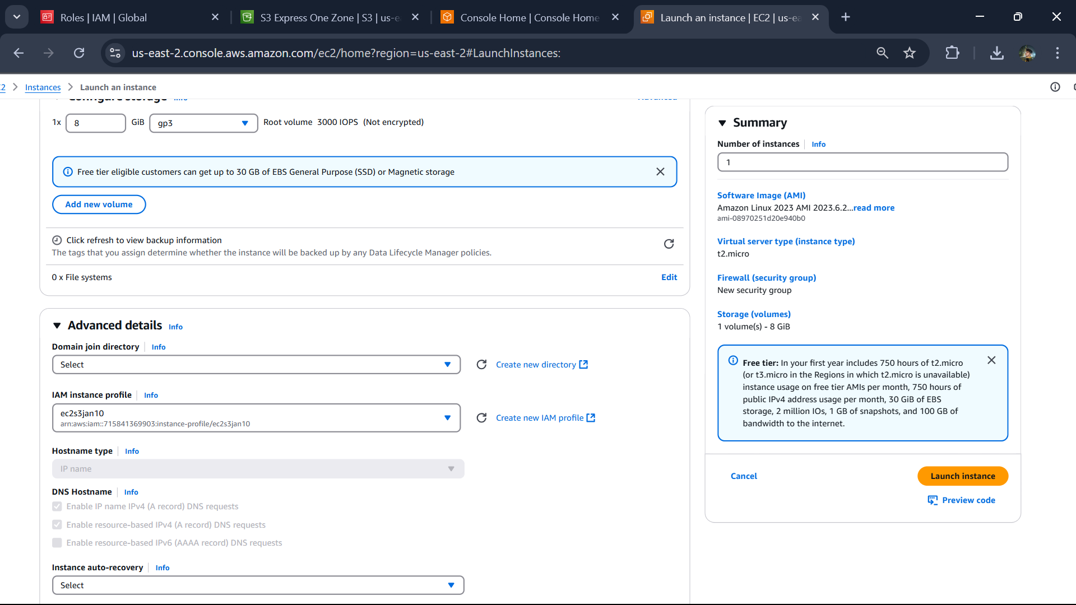

LAB – 8:

Create iam role

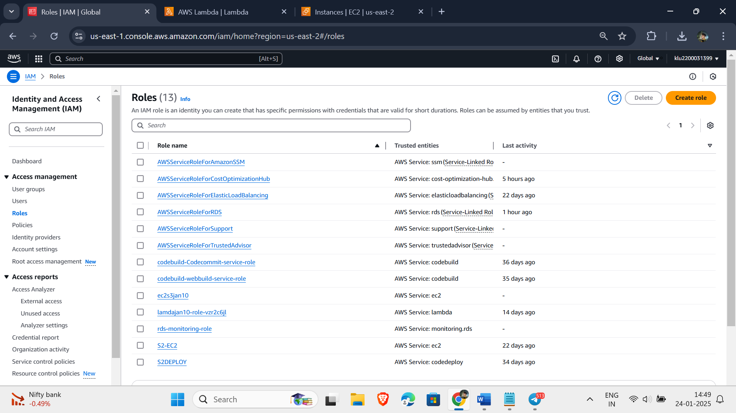

Select lamda with s3fullaccess .

With name lambdas3jan24.

Create a lambda function with name lambdajan24

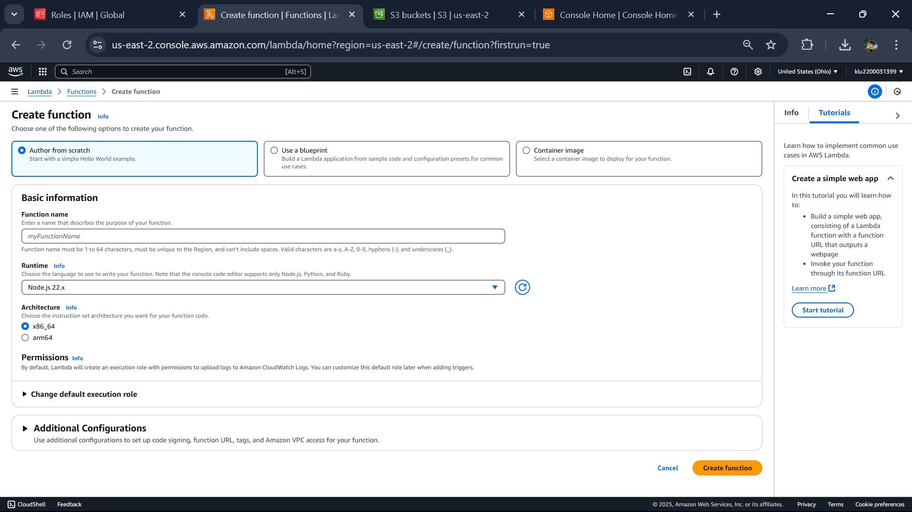

Runtime is python 3.13

Selece use existing role in additional roles.

import logging

import boto3

from botocore.exceptions import ClientError

def lambda_handler(event, context):

bucket_name = event['bucket_name']

region = event['region']

try:

s3_client = boto3.client('s3', region_name=region)

location = {'LocationConstraint': region}

s3_client.create_bucket(Bucket=bucket_name, CreateBucketConfiguration=location)

print(f"Bucket '{bucket_name}' successfully created in region '{region}'.")

return True

except ClientError as e:

logging.error(e)

print(f"Failed to create bucket '{bucket_name}' in region '{region}': {e}")

return False  
this Is the code to paste in editor save it :

Create a test with event name : demoevent

After this test the code . first time it will give error , second time it will give success.

Go to s3 bucket where you can see the bucket s3bucket31399 is created.

After that delete the lambda function.